**Papers written by Australian Maths Software**

8 **SEMESTER ONE YEAR 12**

**MATHEMATICS SPECIALIST**

**REVISION 2**

**UNIT 3**

**2016**

**Section Two**

**(Calculator–assumed)**

**Name**: _________________________________

**Teacher:** ________________________________

**TIME ALLOWED FOR THIS SECTION**

Reading time before commencing work: 10 minutes Working time for section: 100 minutes

**MATERIAL REQUIRED / RECOMMENDED FOR THIS SECTION**

**To be provided by the candidate**

Standard items*:* pens, pencils, pencil sharpener, highlighter, eraser, ruler.

Special items: drawing instruments, templates, notes on up to two unfolded sheet of A4 paper, and up to three calculators approved for use in the WACE

examinations.

**IMPORTANT NOTE TO CANDIDATES**

No other items may be taken into the examination room. It is your responsibility to ensure that you do not have any unauthorised notes or other items of a non–personal nature in the examination room. If you have any unauthorised material with you, hand it to the supervisor before reading any further.

**To be provided by the supervisor**

Question/answer booklet for Section Two.

Formula sheet retained from Section One.

MATHEMATICS SPECIALIST, Semester One Calculator-assumed

**Structure of this examination**

|  | Number of questions  available | Number of  questions to  be answered | Working  time  (minutes) | Marks  available | Percentage of exam |
| --- | --- | --- | --- | --- | --- |
| Section One  Calculator—free | **5** | **5** | **50** | **50** | 35 |
| **Section Two**  **Calculator—assumed** | 11 | 11 | 100 | 100 | **65** |
|  |  |  | Total marks | 150 | 100 |

**Instructions to candidates**

1. The rules for the conduct of this examination are detailed in the Information Handbook. Sitting this examination implies that you agree to abide by these rules.

2. Write your answer in the Question/Answer booklet.

3. You must be careful to confine your responses to the specific questions asked and to follow any instructions that are specific to a particular question.

4. Spare pages are provided at the end of this booklet. If you need to use them, indicate in the original answer space where the answer is continued i.e. give the page number.

5. Show all your working clearly. Your working should be in sufficient detail to allow your answers to be checked readily and for marks to be awarded for reasoning. Incorrect answers given without supporting reasoning cannot be allocated any marks. For any question or part question worth more than two marks, valid working or justification is required to receive full marks. If you repeat an answer to any question, ensure that you cancel the answer you do not wish to have marked.

6. It is recommended that you do not use pencil, except in diagrams.

7. The Formula Sheet is not to be handed in with your Question/Answer booklet.

2

MATHEMATICS SPECIALIST, Semester One Calculator-assumed

6. (6 marks)

Evaluate

32

12 − + 3 +1 ∫*t* ***i*** *t* ***j*** *dt*

(a) (3) ( ) ( )

π + − ∫*sin t* ***i*** *cos t* ***j*** *dt*

(b) (3) ( ( )) ( ( ))

2

03 3

3

MATHEMATICS SPECIALIST, Semester One Calculator-assumed

7. (27 marks)

(a) A moth is flying around in circles following the path

***r***(*t*) = (10*cos*(*t*))***i*** +(10 *sin*(*t*)) ***j*** .

(i) Convert the equation of the path to a Cartesian equation and sketch it on the set of axes below. (3)

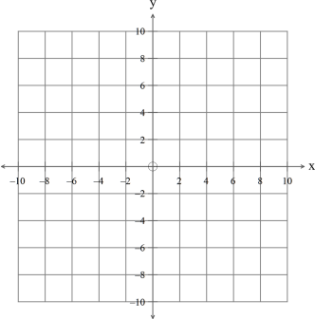

(ii) Prove that the position vector is always at right angles to the velocity vector. (3)

4

MATHEMATICS SPECIALIST, Semester One Calculator-assumed

(iii) Show that and explain why the acceleration is always ***r***(*t*) = −***a*** (*t*) directed towards the centre of the motion. (3)

(iv) Sketch the acceleration and velocity vectors on the diagram at (4) *t* =0*.* (v) Show that the speed of the moth is constant. (3)

5

MATHEMATICS SPECIALIST, Semester One Calculator-assumed

(b) The position vector of a particle at time is given by *t*

( ) ( ( )) ( ( ))

3 3 ***r*** *t* = *sin t* ***i*** + *cos t* ***j***.

The relationship is graphed below:

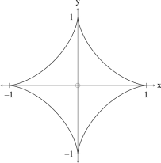

(i) Determine the position of the particle at and indicate the direction of *t* = 0 travel of the particle on the diagram. (3)

(ii) Find the expression for the velocity of the particle. (2)

(iii) Sketch the velocity vector on the graph at (3) 4π *t* = *.*

(iv) Determine the first time that . (3) ( ) 00

⎛ ⎞ =⎜ ⎟ > ***v***

*t* for *t*

0

⎝ ⎠

6

MATHEMATICS SPECIALIST, Semester One Calculator-assumed

8. (3 marks)

ABCDEFG is a cube as shown in the diagram below.

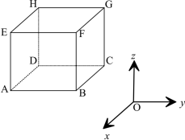

The position vectors of points are *A****,****B****,****C* and *G* ***a***,***b***,***c*** and ***g***. Determine the following in terms of the given position vectors

(a) (2) ***AG*** (b) where is the midpoint of (1) ***OM*** *M AG*.

7

MATHEMATICS SPECIALIST, Semester One Calculator-assumed

9. (13 marks)

(a) The diameter of a sphere is given *PQ P*(1***,*** 2***,*** 4) and *Q*(−3***,*** 6***,*** −4). (i) Find the Cartesian equation of the sphere. (3)

(ii) Find the vector equation of the plane given (3) *PQR R*(1***,*** 1***,*** 1). (iii) Find the vector normal to the plane . (1) *PQR*

8

MATHEMATICS SPECIALIST, Semester One Calculator-assumed

(b) A bird at swooped down on a mouse at with a velocity of (4***,***5***,***6) (9***,***3***,***0) ⎛ ***.*** ⎞

2 5

⎜ ⎟ −

1

m/s

.

−⎝ ⎠

3

(i) How long would the bird take to reach the mouse? (1)

After one second, the mouse is alerted by the bird’s shadow and runs for its

hole at with a velocity of 1 metre per second. (9***,***4***,***0)

(ii) How long does the mouse take to get to its hole? (1)

25

***.***

⎛⎞⎜⎟

0

Instantaneously (i.e. after one second), the bird adjusts its velocity to .

−⎝⎠

3

(iii) What is the change in the bird’s speed? (2) (iv) Does the bird catch the mouse? Explain. (2)



9

MATHEMATICS SPECIALIST, Semester One Calculator-assumed

10. (12 marks)

⎛ ⎛ π ⎞⎞

6

( ~~)~~

⎜ + ⎜ ⎟⎟

12

*i ~~cis~~*

⎝ ⎠

*Rei*

(a) Find . (3) 2

( )

1

−

⎝ ⎠

(b) Given sketch on the set of axes below. (2) 1 2 *z* = 2 + 3*i* and *z* = 2 − 2*i* 1 + 2 *z z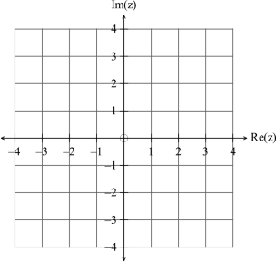*

10

MATHEMATICS SPECIALIST, Semester One Calculator-assumed

(c) Use an algebraic method to find the real numbers such that *x* and *y* (i) (6) 2 3 1 5

. + +

*i i*

*x ~~yi~~*

+ ~~= −~~

1 3

+ −

*i i*

(ii) Find the real numbers correct to two decimal places such that *x* and *y x* + *yi* = 4 + 3*i* . (1)

11

MATHEMATICS SPECIALIST, Semester One Calculator-assumed

11. (6 marks)

Given the vectors

2 3

⎛ ⎞ ⎛ ⎞ ⎜ ⎟ ⎜ ⎟ = − = −

***a b*** 3 2

and

⎜ ⎟ ⎜ ⎟ 1 4

⎝ ⎠ ⎝ ⎠

(a) Find the angle between the vectors. (2) (b) Find the projection of (2) ***a*** on ***b***.

(c) Write down a vector such that (2) ***p b*** ⊥ ***p***.

12

MATHEMATICS SPECIALIST, Semester One Calculator-assumed

12. (17 marks)

(a) Given (4) ( ( )) ( )( ) ( ) ( )2 *p q x* = *x* +1 *x* + 3 and *p x* = *x* −1 find *y* =*qx.*

13

MATHEMATICS SPECIALIST, Semester One Calculator-assumed

(b) Given the function graphed below *f* ( *x*) = *x* ( *x* −1)( *x* +1) 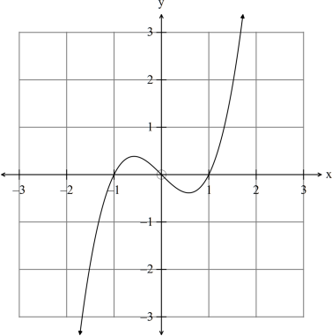Determine the equation of the functions graphed below.

(i) (1)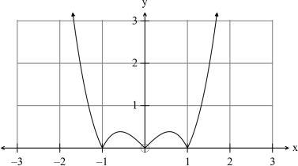14

MATHEMATICS SPECIALIST, Semester One Calculator-assumed

(ii) (2) 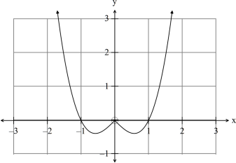

(iii) (3)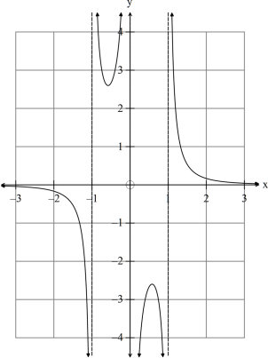

15

MATHEMATICS SPECIALIST, Semester One Calculator-assumed

(c) The function is a polynomial function defined on a domain such that has an *f f* inverse.

Given then ( ) ( )

− −

1 1 3 1 and 3 1

*f* = − *f* − =

(i) find . (1) 2 *f* (1) (ii) find . (1) *f* ( −1 )

(iii) find . (1) ( )

−

1 3

*f*

(iv) determine if the statement is true or false. (1) *f '*( *x*) < 0 for −1< *x* <1 (v) determine if the statement is true or false. (1) −3 < *f* (0) < 3

(d) Given find ( )

2 =*x f x e*

(i) . (1) ( )

−1

*y* = *f x*

(ii) . (1) ( ( ( )))

− −

1 1

*f f f* 1

16

MATHEMATICS SPECIALIST, Semester One Calculator-assumed

13. (4 marks)

(a) Given write down the domain and range of ( ) ( )

2

*f x* = 1− *x* and *g x* = *x*

*f* ( *g* ( *x*))*.* (2)

(b) (i) Given , determine the equation of the inverse function ( ) =1+*x h x e* ( ) (1) −1 *y* = *h x .*

(ii) Determine (1) ( ) − *h .*

1 2

17

MATHEMATICS SPECIALIST, Semester One Calculator-assumed

14. (4 marks)

Complete

*_______*

⎧ ≥ = − + = ⎨⎩ <

for

*x*

0

*y x _______*

2 2

(a) (1) 0

for

*x*

⎧ −

1

*x*

= − = ⎨⎩ −*_______*

11for

*y x*

(b) (1) *x*

for

*_______*

(c) Hence solve algebraically, showing all working. (2) −2 *x* + 2 = 1− *x*

18

MATHEMATICS SPECIALIST, Semester One Calculator-assumed

15. (3 marks)

The graph below has the equation . ( )( )

*x a x b*

− −

*yx c*

=−

2

( )

Determine the values of (3) *a,b* and *c.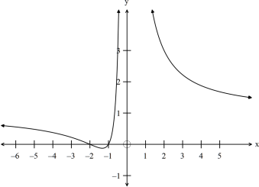*

19

MATHEMATICS SPECIALIST, Semester One Calculator-assumed

16. (5 marks)

Use de Moivre’s Theorem to prove that . ( ) ( ) ()()5 3 *cos* 5θ =16*cos* θ −20*cos* θ+5*cos*θ(5)

**END OF SECTION TWO**

20